**Manual for the “GUV analysis program”**

GUV_AP: multifunctional FIJI-based tool for quantitative image analysis of Giant Unilamellar Vesicles

Taras Sych1,2,3,4,§, Thomas Schubert1,2,3,§, Romain Vauchelles4, Josef Madl1,2,3, Ramin Omidvar1,2,3, Roland Thuenauer1,2,3, Ludovic Richert4, Yves Mély4,* and Winfried Römer 1,2,3,*

1Faculty of Biology, Albert-Ludwigs-University Freiburg, Schänzlestraße 1, 79104 Freiburg, Germany, 2Centre for Biological Signalling Studies (BIOSS), Albert-Ludwigs-University Freiburg, Schänzlestraße 18, 79104 Freiburg, Germany, 3Freiburg Center for Interactive Materials and Bioinspired Technology (FIT), Albert-Ludwigs-University Freiburg, Georges-Köhler-Allee 105, 79110 Freiburg, Germany,4 Laboratoire de Bioimagerie et Pathologies, UMR 7021 CNRS, Faculté de Pharmacie, Université de Strasbourg, 67401 Illkirch Cedex, France

§Contributed equally

*To whom correspondence should be addressed:

Winfried Römer: [winfried.roemer@bioss.uni-freiburg.de](mailto:winfried.roemer@bioss.uni-freiburg.de)

Yves Mély: [yves.mely@unistra.fr](mailto:yves.mely@unistra.fr)

1. **Image preparation**

To be suitable for script processing, the image raw data has to comply with several requirements (Figure 1):

* Use raw gray scale images (without any marker such as scale or color bar).
* The macro is implemented to process up to 3 color channels, hence the number of channels cannot be higher than 3.
* Although images can contain several frames/slices, only the first frame and/or slice will be processed.
* The images for processing have to be collected in one separate folder. They must have the same extension.

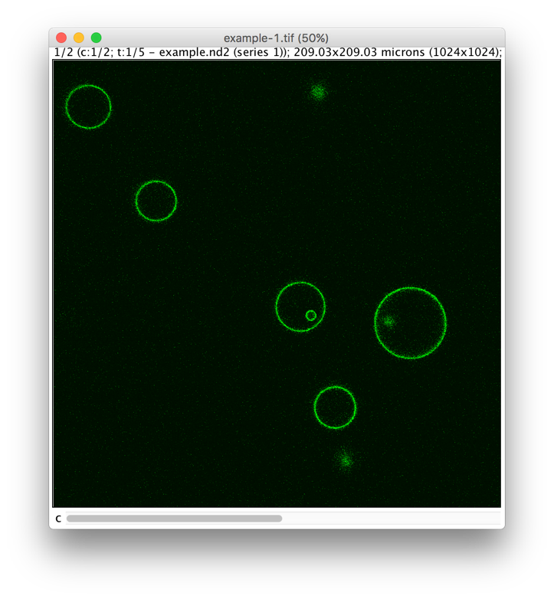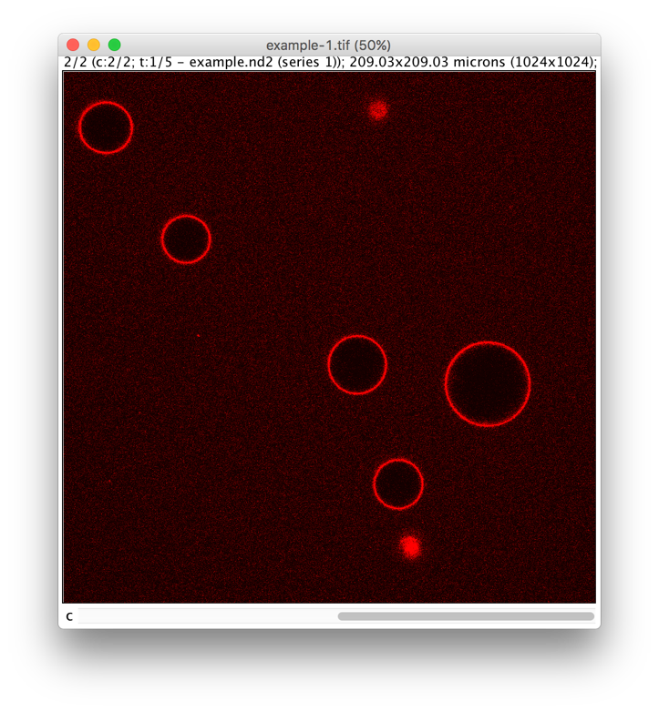

**Figure 1: Raw data.** Example of a two-channel time lapse image suitable for processing. A) Membrane channel; B) Membrane-bound protein channel.

1. **Input parameter section**

Download the “GUV-AP.zip” from <https://github.com/taras-sych/GUV-AP>. The archive contains a macro file, the manual and the raw data images (“test_homogeneous_GUVs.tif” and “test_phase_separated_GUVs.tif) used to illustrate the GUV analysis macro performance in the manual.

The script was successfully tested on Windows 7, Mac OS X El Capitan and Linux Ubuntu 10.04 LTS. Download and unpack FIJI: https://imagej.net/Fiji. Download the version appropriate to your system. Open the unpacked folder, and then run FIJI. After the first opening, FIJI will ask for an update; press “YES”, update it and relaunch FIJI. Before using the macro it is necessary to upgrade FIJI to the version 1.51 (Help>>Update ImageJ). To open the script, please drag the GUV-AP.ijm file to the FIJI window, or go to Plugin>>New>>Macro and the macro redactor will open. In the Macro redactor window, go to File>>Open and select the GUV-AP.ijm file. There are two possibilities to enter parameters. The first category of parameters can be set directly in the script body (Figure 2). This group contains parameters, which should not be changed frequently:

* tc – thresholding coefficient of ROI definition (see chapter 3)
* min_detected – the minimal area (in pixels) of the detected particle (see chapter 3)
* ce – circular extension coefficient required for ROI definition method of *FIT circle* (see chapter 4)
* file extension – the extension of raw data files
* alpha_step – the sampling angle (see chapter 7)
* setBatchMode(true/false) – activates/deactivates BatchMode of the Macro processing

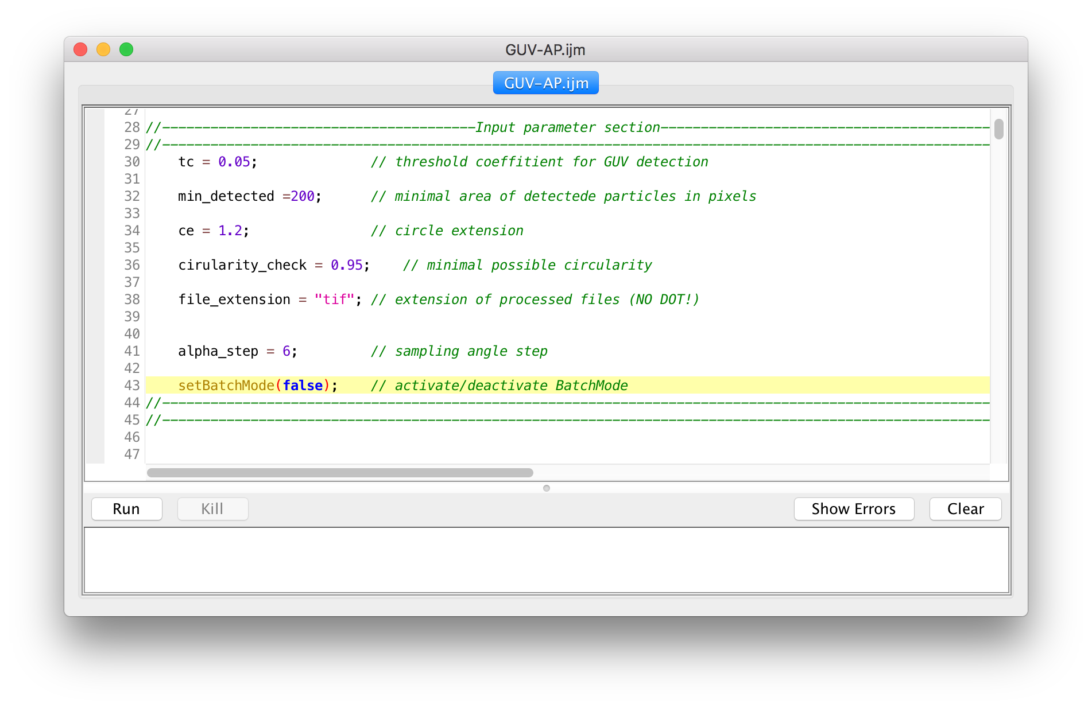

**Figure 2: Input parameters.** Input parameter section of the script.

The second group of parameters can be set using the graphical user interface after launching the script (Figure 3). These parameters should be modified routinely.

To launch the script, please press the “Run” button on the bottom left corner of the macro redactor. First, it will ask for the directory where your images are stored for processing; please select it. Then, the input windows will appear one by one:

* “Plot profile” - window. The number of channels for analysis should be selected in this window. A short meaningful name for each color channel can be given. The total number of channels selected should correspond to the total number of channels in the raw data file.
* “ROI definition” - window. Here, the channel for GUV detection has to be selected. Each color channel as well as the sum of all channels can be chosen.

To enhance the accuracy of the definition of GUV position and to eliminate false positives, two operations should be performed:

* The **circularity check** decreases the false detection of circular objects. This feature can only be used when GUVs appear as closed circular objects (e.g. non-phase-separated GUVs) on the image used for GUV detection.
* Phase-separated GUVs appear as circular segments. For each circular segment, the best-fitting circle is found, so the centers and the radii can be estimated. When the phase-separated GUVs are represented by a series of unconnected circular segments, the usage of all these segments at once can enhance the accuracy of the GUV detection. The **GUV stitching** procedure determines which segments belong to the same GUV.

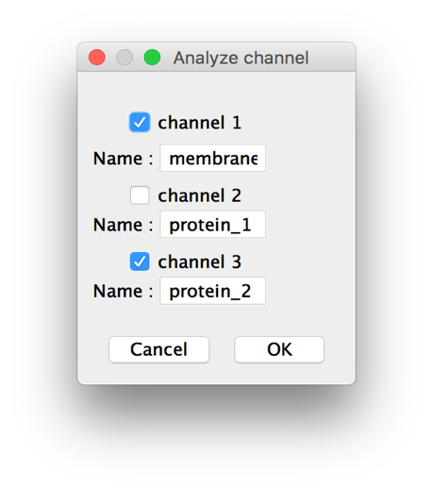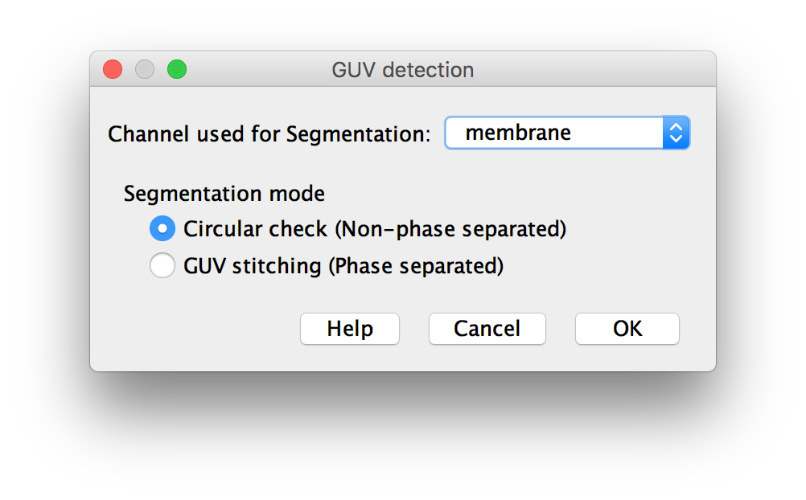

**Figure 3: Input parameters via graphical user interface.** A)Select channels for analysisand specify the names of selected channels; B) Select channels used for segmentation (GUV detection) and segmentation mode.

After these parameters have been chosen, the script runs. There are no more actions required from the user; the results are displayed as described in chapter 8. The following chapters explain step-by-step the working procedure of the script, which may help to select the proper parameter values.

1. **GUV detection**

The directory determined by the user (see chapter 2) will be examined based on the files with the extension defined by the user as file_extension (see chapter 2). If no file with such extension is detected, the script will show an error message. If multiple files with such extension are present, each file will be processed one by one. As described in chapter 1, the image file can contain multiple GUVs and multiple color channels. First of all, channels are split. Each channel is renamed as proposed by the user in “Plot profile” (see chapter 2). In addition, the “overlay” channel is created (Figure 4).

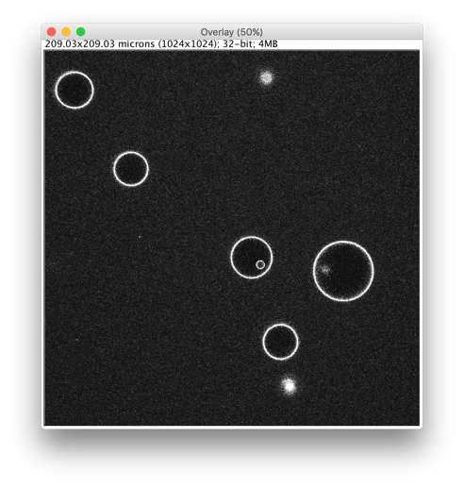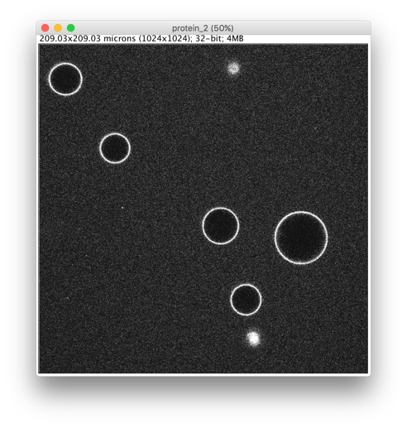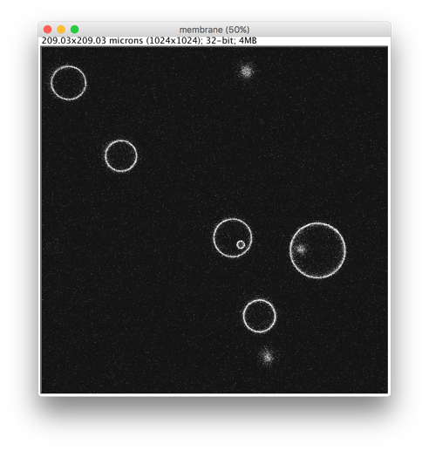

**Figure 4: Split channels.** Channel 1 and channel 2 are split and the sum of all channels (Overlay) is created.

GUV detection is performed using the user-selected channel. In this case, it is the “membrane” channel. The threshold of the channel signal is determined, as:

$$T= I_{min}+tc\left(I_{max}- I_{min}\right) \left(1\right)$$

where *Imin* represents the minimum intensity gray value of the image. *Imax* is the maximum intensity gray value of the image, and *tc* is the user-defined threshold coefficient. According to (1), *tc* represents the fraction of intensity (in gray values), which is eliminated by applying the threshold.

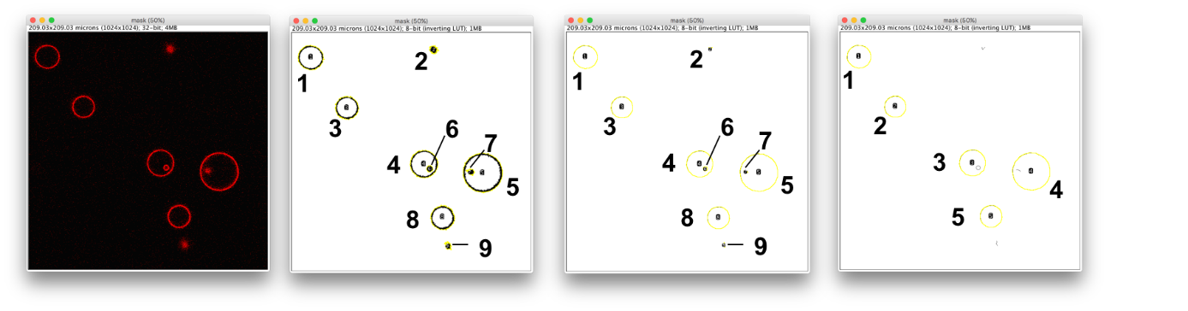

A

B

C

D

**Figure 5: Detection of non-phase-separated GUVs.** A) Channel with the threshold applied – the gray values of pixels marked in red are above the threshold; B) Particles detected; C) Skeletonized particles detected; D) Recognized particles after GUV stitching.

The thresholded image (Figure 5A) is analyzed with the ImageJ *Particle Analyzer*. Each group of pixels with gray values above the threshold and a size above the user pre-defined value (min_detected) is detected and added to ImageJ ROI Manager (Figure 5B). Image skeletonizing is used to achieve more accurate GUV detection. This operation extracts a one pixel-thick skeleton of each circular segment (or full circle). This thin GUV rim is then used for a more accurate fit of the GUV by a circle.

1. **Circularity check**

Non-phase-separated GUVs appear as fully closed circles. Each detected particle represents a distinct GUV (Figure 5A, B, C) of circular shape. Deletion of non-circular particles helps to avoid any possible false detection: GUVs out of focus, e.g. aggregates of GUVs or aggregates of free membrane marker.

The circularity parameter is the shape descriptor defined as:

$$c= 4π\frac{A}{P^{2}} (2)$$

where *A* is the particle area and *P* is the particle perimeter. For a perfectly circular object, *с* is equal to 1*.* Particles with *с* values below 0.95 are not considered as circular. Using this method, the particles 2, 6, 7 and 9 in Figure 5C are discarded (Figure 5D). The result of GUV detection for non-phase-separated GUVs is depicted in Figure 6.

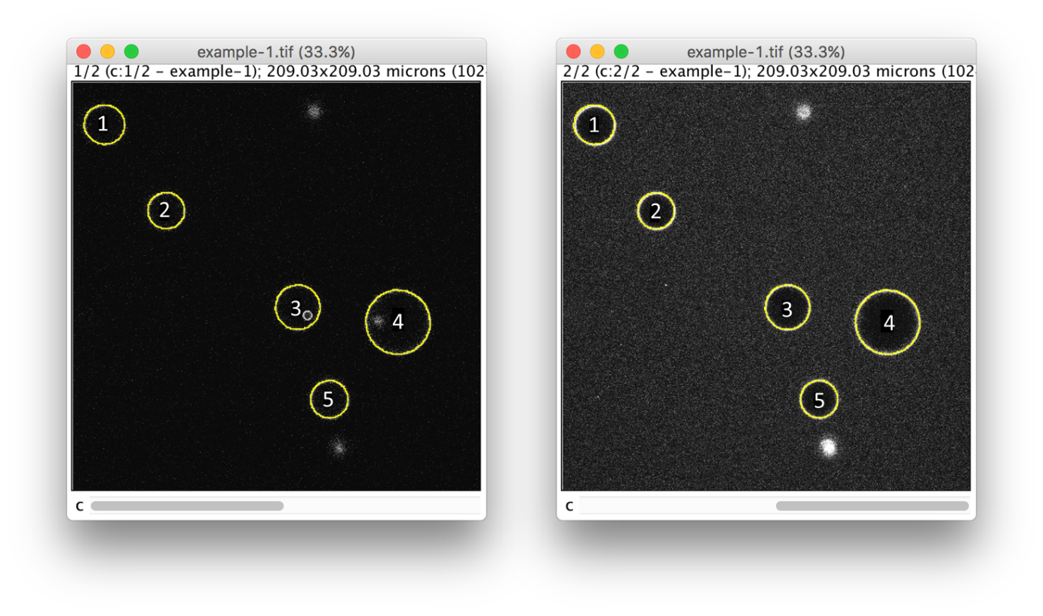

A

B

**Figure 6: Result of GUV detection for non-phase-separated GUVs** shown on the raw data images. A) Membrane channel; B) Protein channel.

1. **GUV stitching**

Phase-separated GUVs appear as circular segments. In principle, any circular segment can be used for the circle reconstruction by the FIJI functionality *Fit Circle*. However, for precise reconstruction from a single circle segment, the latter has to cover at least one third of the circle perimeter. Frequently, GUVs appear as a series of unconnected circular segments (Figure 7A, B, C). Through the initial particle analysis, these GUV segments are detected as separate particles (Figure 7B, C). To enhance the detection precision and avoid multiple-processing of the same GUV characterized by several circular segments (phase domains), a GUV stitching procedure has to be performed. This procedure determines which segments belong to the same GUV by the following algorithm:

* For each detected circular segment *S* (Figure 7C) the best fitting circle is found.
* The center position (*xc; yc*) and the radius *R* for each circle are calculated.
* For two circular segments *S* and *S’* , the following equation:

$$\sqrt{{\left(x_{c}^{}- x_{c}^{'}\right)}^{2}+{(y_{c}^{}-y_{c}^{'})}^{2}} <R^{}+R^{'} (3)$$

applies only, if these two segments belong to the same circle.

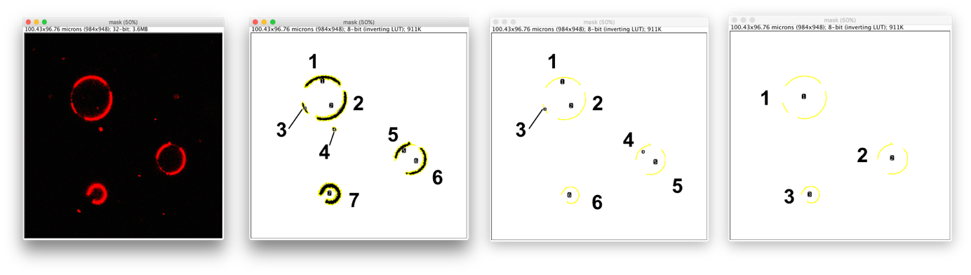

A

B

C

D

**Figure 7: Detection of phase-separated GUVs.** A) Image after threshold applied– the gray values of pixels marked in red are above the threshold; B) Particles detected as a series of separate GUV segments; C) Skeletonizing of GUV segments; D) GUV stitching procedure combines GUV segments which belong to the same GUV.

After the GUV stitching procedure, the circular segments, which represent the same GUV, are defined and combined for the subsequent center and radius calculation. The result of GUV detection for phase-separated GUVs is depicted in Figure 7D.

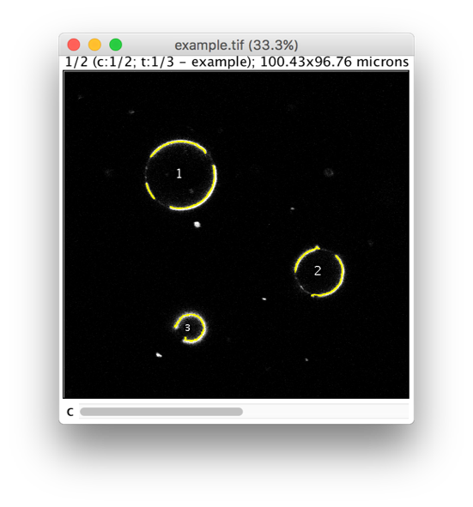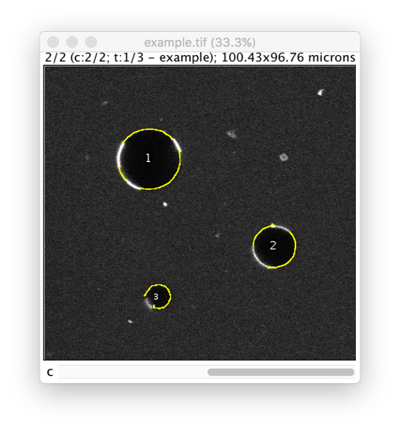

A

B

**Figure 8: Detection of phase-separated GUVs** shown as raw data images. A) Membrane channel; B) Protein channel.

1. **Circle centers and radii calculations**

When all GUVs are detected, the center coordinates and the radius of each GUV are calculated. For this purpose, the ImageJ functionality *Fit Circle* is used. This procedure estimates the best fitting circle for a given selection. In our case, the selections correspond to the detected GUVs after the circular filter or the GUV stitching procedure. The position of the center is immediately calculated in a precise manner, but as the selections are skeletonized, the radius of the circle *R* has to be increased to take into account the signal from the full thickness of the GUV rim. For this, the user pre-defined circular extension parameter *ce* is used:

$$R_{e}=ce∙R (4)$$

Normally, the *ce* value can vary between 1.05 and 1.1. The value *Re* is used as the radius of GUV – containing circular areas for free protein value extraction (see chapter 5).

1. **Background and free protein value extraction**

The background and “free protein” values of each channel are important for the proper quantification of the fluorescence intensity at the rim of the GUVs and for the estimation of the protein binding efficiency. The background is the fluorescence signal produced by noise in each color channel. The best way to extract this value is to calculate the mean fluorescence intensity inside the detected GUVs. In order to do this, the round shaped ROIs with centers at the centers of GUVs and the radii three times smaller than the radii of the GUVs are applied (Figure 9A, B). To determine the free protein value for each color channel, the areas of the images which contain GUVs or other objects (e.g. GUV aggregates, GUVs out of focus) are deleted from all channels. The results of such deletion are depicted in Figure 9C and D. The remaining signal represents the fluorescence from the protein which is not associated with the GUV (Figure 9B). In the membrane color channel, there is no fluorescence signal outside the GUV contours (Figure 9A); so in this channel the “free protein signal” is calculated as NaN (Not a Number). The signal from the membrane channel does not require normalization; hence the “free protein value” for the membrane channel is set to 1.

**Figure 9: Calculation of the background and “free protein” values**. A, B) Background value extraction of the membrane (A) and protein (B) channel; C, D) “Free protein” value extraction of the membrane (C) and protein (D) channels.

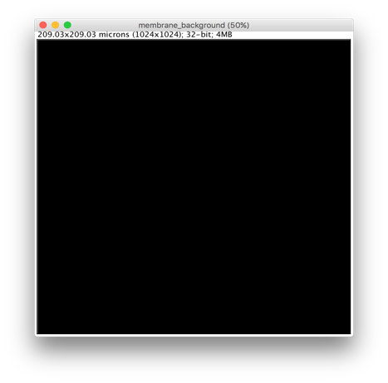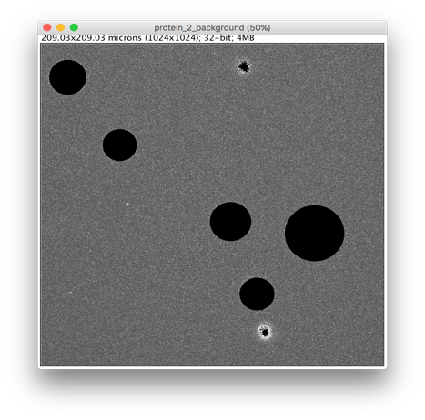

C

D

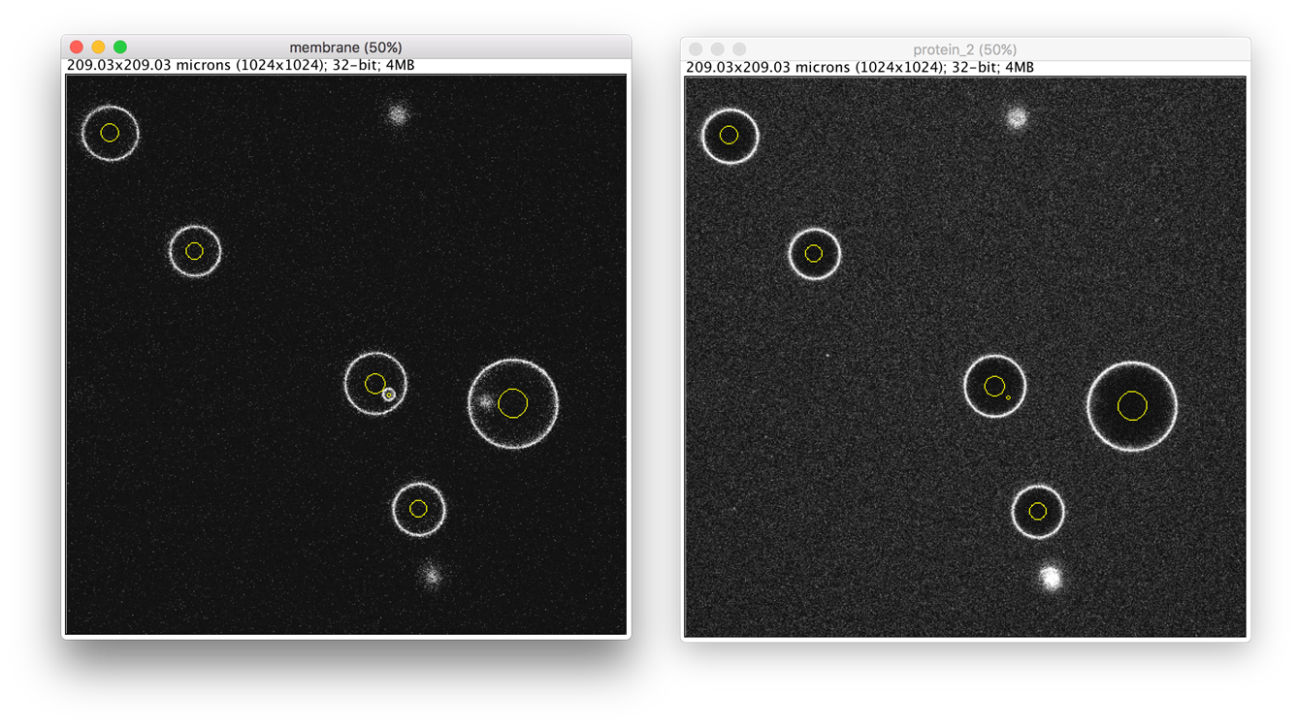

A

B

1. **Annular selection**

GUVs are detected as closed circles of certain radii. However, GUVs appear on the images as rings of certain thicknesses. The most precise way to extract the fluorescence intensity gray value from the GUV rims is to use the annular selection for each GUV. The “skeleton” (one pixel-thick ring; Figure 10A) of such annular selection is represented by the circle obtained by the *FitCircle* procedure (see chapter 4). In principle, such thin ring selection can already be used to extract some value of fluorescence intensity on the GUV rim. However, the thicker ring selection guarantees a more precise and accurate fluorescence signal extraction. To make the skeleton selection thicker, the ImageJ procedure *Erode* was applied (Figure 10B).

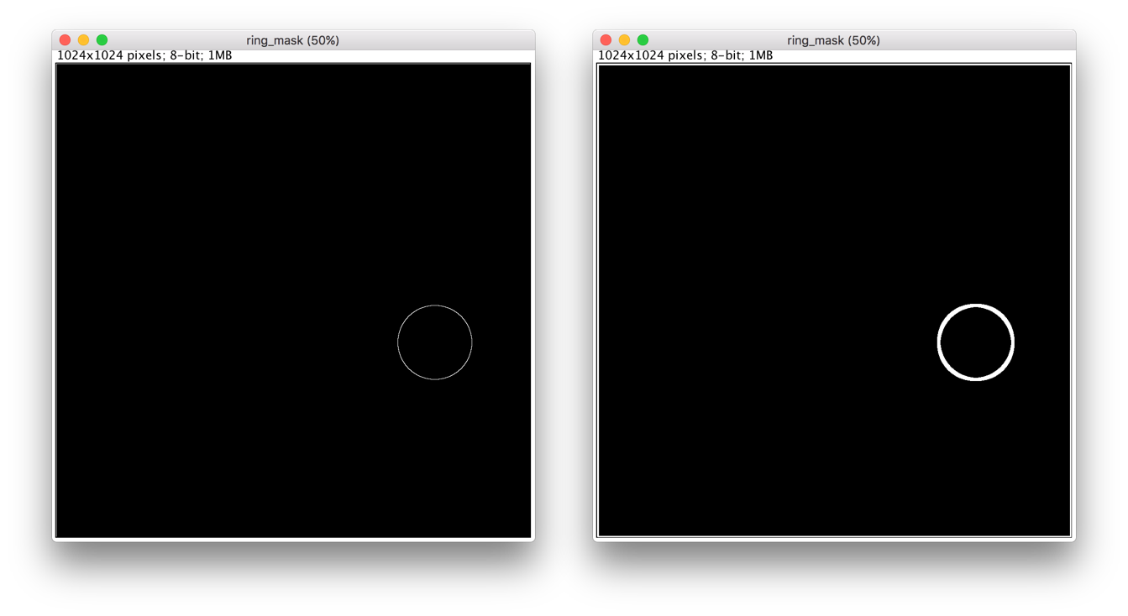

A

B

**Figure 10: Annular selection**. A) Skeleton of the GUV; B) Annular selection obtained by erosion of (A).

1. **Binding efficiency calculation**

For each color channel the bottom threshold value $T$ is calculated as:

$$T= \frac{〈Free protein〉- 〈Background〉}{2} \left(5\right),$$

where $\left\langle Free protein\right\rangle$ is the mean fluorescence intensity signal from the free protein in solution and $〈Background〉$ is the background value for each channel. The extraction procedure of both values for each channel is described in chapter 5.

The protein binding efficiency $ε$ is calculated using the values of the mean protein signal on the GUV contour and the mean free protein signal outside of the GUV contour (Figure 10) by the following expression:

$$ε=\frac{\left\langle Bound protein\right\rangle - \left\langle Free protein\right\rangle }{\left\langle Free protein\right\rangle } \left(6\right),$$

where $\left\langle Bound protein\right\rangle$ is the mean fluorescence intensity signal from the protein located on the vesicle contour and $\left\langle Free protein\right\rangle$ is the mean fluorescence intensity signal from the free protein in the solution, extracted from the area of the image that surrounds the GUV. This value represents quantitatively the contrast between the GUV rim signal and the protein background level. The higher the value of the binding efficiency, the more protein molecules are bound to the GUV membrane. Consequently, this value represents quantitatively the efficiency of protein binding.

A

B

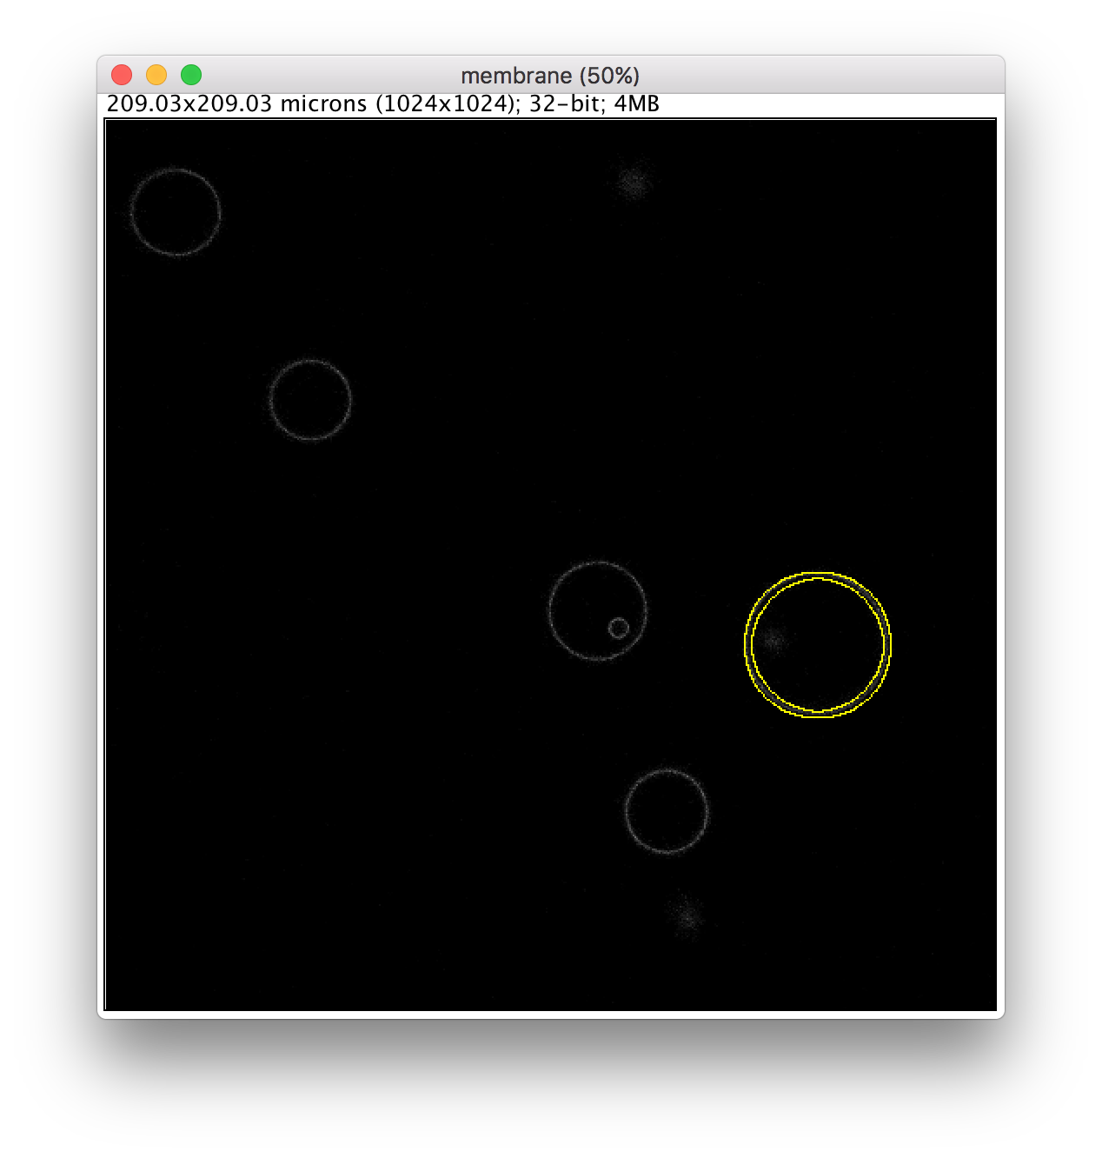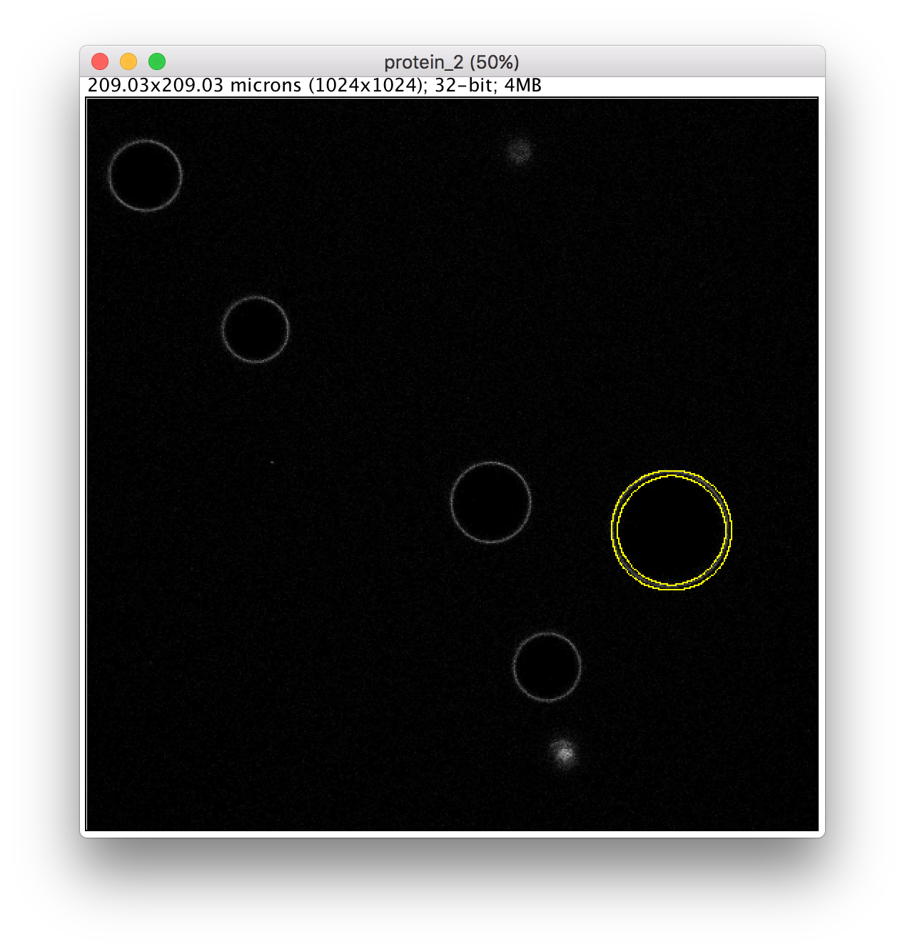

**Figure 11: Binding efficiency calculation**. A) Membrane channel; B) Protein channel.

1. **Circular profile extraction**

For various applications (see main manuscript), it is required to monitor the variations of the fluorescence signal along the GUV contour – the so-called circular intensity profile. To do this, each GUV is sampled on a number of segments covering a sampling angle, which is defined by the user (Figure 12 A):

$$N= \frac{360}{alpha_step} (7)$$

For each segment, the average intensity value is extracted. Hence, the circular intensity profile (Figure 12 E) is extracted for each channel (Figure 12 B, C). For the protein channel, the value extracted for each segment is further normalized to the free protein intensity value (as explained in chapter 5).

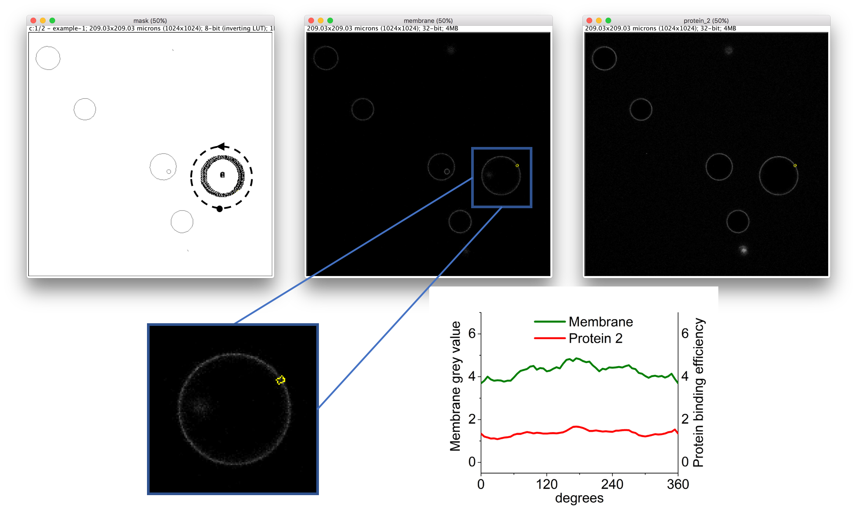

E

D

A

B

C

**Figure 12: GUV profile extraction.** A) For each GUV, the corresponding annular selection is sampled on circular segments (ROIs); For each ROI, the fluorescence intensity signal is extracted in membrane channel (B) and protein channel (C). The black dot and arrow in (A) indicate the start and direction of circular profile extraction, respectively. D) Zoomed GUV-containing area. E) Resulting circular profiles extracted from membrane channel (green curve) and protein channel (red curve) of the GUV depicted in A.

1. **Data output**

The data output files are added in the folder with the raw data files, in a subfolder named “Results – hh:mm”, where hh:mm is the time when the script run started (Figure 13).

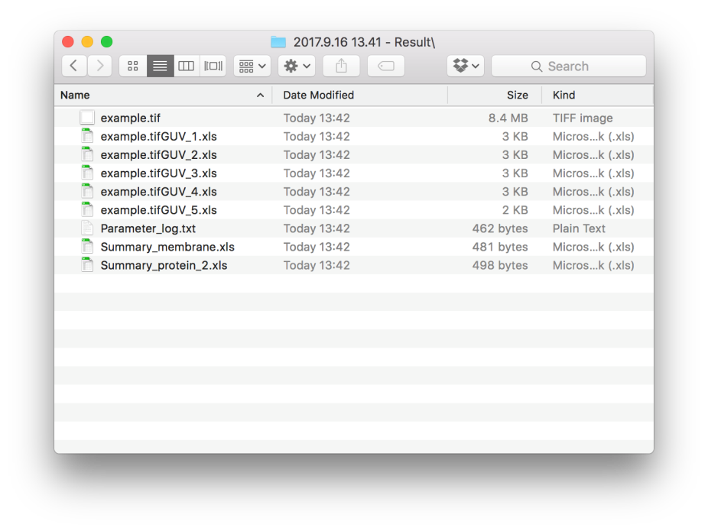

**Figure 13: Data output files location.**

This folder contains the *.tif files, i.e. the raw data files processed from marked GUVs. For each GUV, the circular profiles for all color channels are stored in the .xls file (Figure 14B). The name of such .xls file contains the name of the image number according to the mark on the corresponding .tif file. The file Parameter_log.txt (Figure 14A) contains all parameters used for analysis. The summary .xls files contain the data for protein binding efficiencies (Figure 14C).

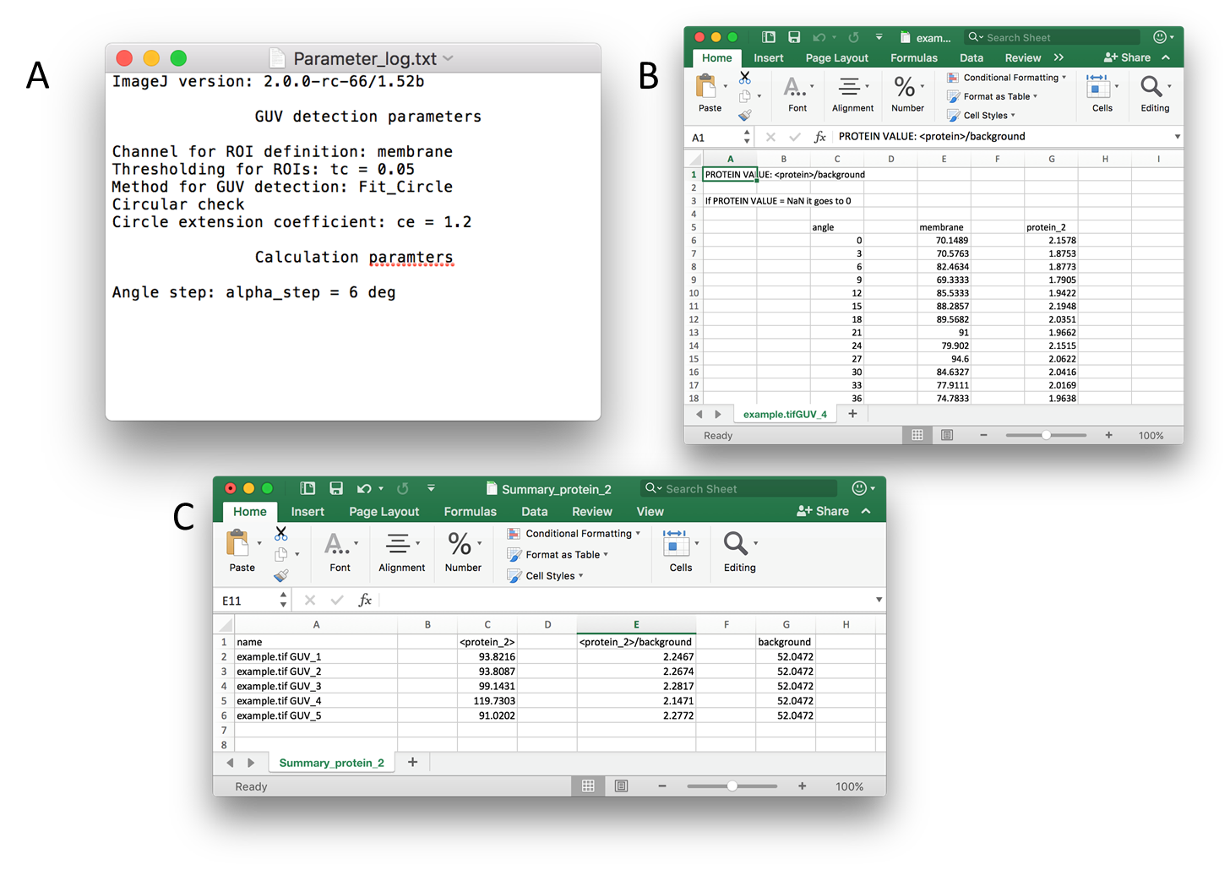

**Figure 14: Appearance of output files.** A) Parameter_log file; B) Circular profiles of all color channels for an individual GUV; C) Binding efficiency summary for the protein channel.